KOCAELI UNIVERSITY DEPARTMENT OF ENGINEERING



OBSTACLE DETECTING ROBOT CONTROLLED VIA ARDUINO WITH BLUETOOTH MODULE WITH SOFTWARE WRITTEN IN C#

Student Name:Yusuf Tuğrul ETYEMEZ
Student Number:130207091

Adviser: Yrd. Doç. Dr. Oğuzhan Karahan

KOCAELI, 2016

Project Description:

This project consists of a remote controlled robot that detects obstacles in three directions and also moves in four (right, left ,forward ,backwards) directions to overcome the obstacle.

Parts:
Arduino Uno
HC-06 Bluetooth module
HC-SR04 ultrasonic sensor
DC Motor x2 with 2 wheel
A Free wheel
9V battery x2
L293D

Arduino Uno:

Arduino is a open source software platform which create for electronic projects.It consist of pcb board, cpu, compiler and some tools which install programs into the cpu.
Most popular board of arduino family is Arduino Uno R3 :
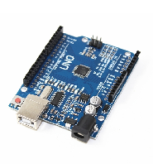
Arduino uno has ATmega328 microcontroller, 32 KB memory. It is working with +5V dc power. On the right side it has 14 digital i/o pins. Six of them which they have tilda (~) symbol are supports PWM output. On the right side of arduino has 6 analog input pins.

Ultrasonic Distance Sensor:
Ultrasonic sensors can detect objects without contact.In sound wave classifications; between 20Khz and 1Ghz sounds called as ultrasonic sound. Ultrasonic sensors work in this frequency range which humans couldn’t perceive
This sensors simply consist of microphone and speaker.It produces ultrasonic sound waves in 40Khz frequency. Sensor transmit this soundwaves from the speaker. If soundwaves crash with an object and reflected back again, microphone can detects.
In this point, important thing is the returning time of the signal.Distance of object to the sensor will be calculate in this point.

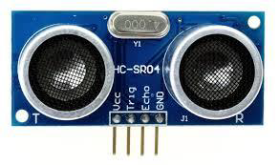
It has 4 pins; Vcc(+ voltage), GND, Trig(trigger for measuring) and echo pins.
Main properties of the ultrasonic distance sensor are ;

- • Working at — 5V DC
- • Current consumption — 15 mA
- • Working frequency — 40 Hz
- • Maximum Sight — 4 m
- • Minimum Sight — 2 cm
- • Sight angle — 15 derece
- • Size — 45mm x 20mm x 15mm

L293D MOTOR DRIVER COMPONENT :

Microcontroller’s outputs are insufficient for control DC motors and Step motors directly.We use motor driver L293D which controls two motors on two way and independent from each motors.

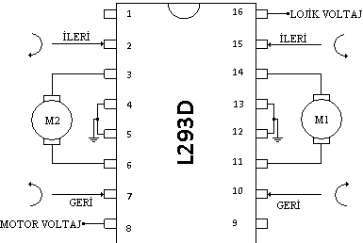
L293D motor drive works possible 4,5 V and 36V and maximum 1,2A current limitation. Also, you can do PWM control with 1. and 9. enable pins.With PWM control you can configure motor speed.

HARDWARE:
In hardware part of this project we will show parts which we use in our project on a bread board. We use Fritzing Program to draw this circuit.

